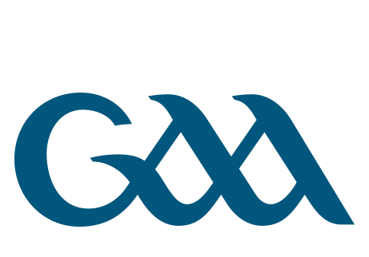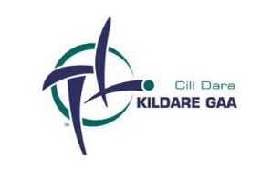 Cumann Lúthchleas Gael
Coiste Chontae
Chill Dara
Kildare GAA Hawkfield Centre of Excellence
Milltown Road, Newbridge, Co Kildare
Fón: 045-430602 e-phoist: kildaregaa@gmail.com
Deontas Gaeltachta 2022

Foirm Iarratais
Ainm agus Sloinne ______________________________________________________________
Seoladh _______________________________________________________________________
Fón __________________________________________________________________________
E-phoist _______________________________________________________________________
Dáta Breithe ___________________________________________________________________
Cumann _______________________________________________________________________
Uimhir Cláraithe sa Chumann ______________________________________________________
An t-ainm atá ar do scoil féin _______________________________________________________
Ainm an Choláiste Samhraidh ______________________________________________________
Cén mhí (Meitheamh/Iúil/ Lúnasa___________________________________________________

An dáta deiridh chun an fhoirm iarratais a fháil: 15ú Bealtaine 2022

You may apply for Deontas Gaeltachta 2022
1: If you are attending Second Level School.
2: If you have not previously availed of Deontas Gaeltachta.
3: You must submit a letter of reference including your current registration number on official club note paper from the secretary of chairman of your club.
4: You must submit a copy of the acceptance notice from The Coláiste.

Once completed this form should be returned to kildaregaa@gmail.com

