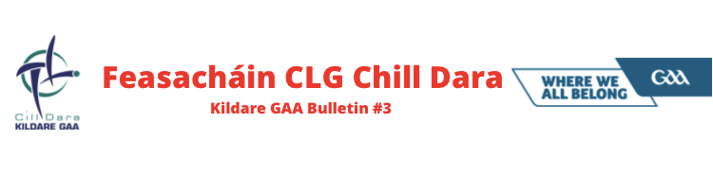
A Chairde,

This week’s 3 page newsletter will focus on the usual topical items along with providing a brief overview of Kildare GAA Coaching & Games and a Kid’s Word Search.

- Congratulations to Rian Boran, Paul Divilly, James Burke & Jack Sheridan who were named on the Champion 15 Team of the Year for 2020. Special mention to Paul who was also named Christy Ring Cup Player of the Year.

- The GAA Covid Advisory group will be issuing guidance as to when collective training / games etc can re-commence following the release of the revised Government’s Plan for Living with Covid-19.

- GAA Congress takes place next weekend 25th / 26th February. Motions for consideration were issued to Club Secretaries on Tuesday. A Special Co Board Meeting with Clubs will take place next Tuesday night 23rd February to discuss all motions on the agenda.

- The Kildare Hurling Goalkeeper Pathway was launched before a large attendance last night - congratulations to authors Paddy McKenna, Mark Doyle, Paul Dermody & John Doran for their hard work collating, designing and launching the document. The pathway can be downloaded from the Kildare GAA website.

- GAA Solo is back. The very successful initiative to keep teenagers active during Lockdown 1 is back! The initiative is designed to promote positivity, physical activity and wellbeing among young people, while encouraging them to stay at home and follow HSE guidelines at the same time. There will be different challenges each week for the remaining 3 weeks of the programme. To get involved, students and teachers record videos of themselves doing the various challenges and upload them to Twitter, Facebook or Instagram. There will be prizes each week sponsored by O'Neills. To find out more visit https://learning.gaa.ie/gaasolo

- A reminder that the closing date for Sports Capital Grant applications is 1st March.

- The Club Safety check is fast approaching – Clubs this year will be asked to perform a safety check on all structures within your Club Grounds during the months of March, June & October. Development Officer Petria Dobbins will be in touch shortly with documentation.

- This year’s "Meitheal Chill Dara" will be held on 6th March via Zoom with participants encouraged to register in advance at: https://cilldaralegaeilge.ie/pleanail-teanga/ or https://zoom.us/meeting/register/tJwqcO6qqDkuGtDE2Xf29hPQc09KFfD7oNtU

- The GAA are currently conducting a National Survey ahead of a new defibrillator campaign for clubs and feel it is important to gather and collate information on the current status of defibrillators stored on club grounds. It is vitally important that all Clubs compete the survey issued to Secretaries. The below article shows the importance a working defib within in a Club setting. https://www.irishtimes.com/life-and-style/health-family/my-chance-of-survival-without-cpr-was-about-1-1.4380827?mode=amp

- “Take Control with Stress Control” webinar series will take place on Monday 22nd Feb (Controlling Panicky Feelings and Getting a Good Night’s Sleep) & Thursday 25th Feb (Controlling your Future). You can pre-register your attendance for both events on www.stresscontrol.ie

Kildare GAA Coaching & Games
Whilst our Games Promotion Officers and Games Development Administrators haven’t been able to attend schools, they have been busy carrying out online training sessions. So far we have seen 73 schools and over 4000 children taking part.
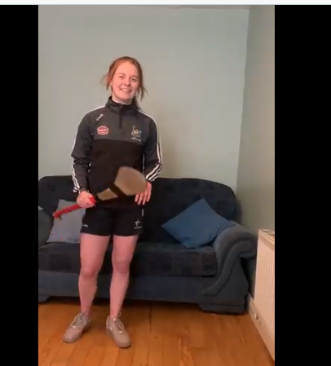
Our coaches are also in constant contact with their clubs helping to organise and conduct training sessions, skills challenges, wall-ball sessions and cooking demonstrations.
There are around 300 Under 17 and Under 20 athletes taking part in interactive sessions in preparation for the return of inter-county activity. It is hoped that this programme will roll out to under 15’s and under 16’s in the coming weeks. Links for the session will be sent to clubs prior to commencement. If there are any further queries, please contact GDA Paul Divilly @ paul.divilly.gda.kildare@gaa.ie or 0834840347.
The upskilling of clubs with regard to the TURAS programme is ongoing. There are currently 17 online foundation courses ongoing. If there is any club or coach with any queries, please get in touch with GDA Declan O’Toole @ Declan.otoole.gda.kildare@gaa.ie or 0876642369.
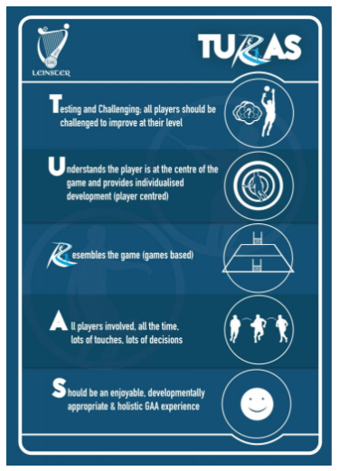
Preparations for this year’s Cúl Camps are well underway. Kildare will have 61 camps this year, details of which will be published next month. Keep an eye on https://www.kelloggsculcamps.gaa.ie/ for further information.

Word Search

Dermot Earley recently featured on TG4’s Laochra Gael Show. Can you locate the topics discussed in the documentary (words listed below)? Send your answers to pro.kildare@gaa.ie

Family GaelicPark Galway
Health JohnnyDoyle Kildare
Leader Leinster McGeeney
NewYork Roscommon Sarsfields
Tipperary AllIrelandFinal Army
DonnollysHollow

Stay Safe
Dave Cahill
PRO Kildare GAA

