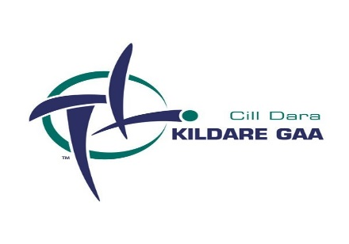
A Chairde,

I hope you are keeping safe and well – this week’s 2 page newsletter will focus on current topical items along with providing a brief introduction to the Kildare GAA Health & Wellbeing Committee.

- Tomorrow Saturday 13th February marks the 100 year anniversary when Tim Clarke was elected as Kildare GAA County Board Secretary - to mark the occasion we will be publishing an article on our website and social media channels.

- The GAA Covid Advisory group this week advised they hope to provide guidance as to when collective training / games etc can re-commence following next week’s release of the revised Government’s Plan for Living with Covid-19.

- A reminder that Player Regrading forms are to be submitted to CCC by 5pm next Friday 19th February. Clubs still involved in the Adult Hurling and Adult Football Championships 2020 will be asked to submit their Regrading once those competitions have been completed. Also Club Amalgamation Form 2021 are also due to be submitted before the March County Board Meeting.

- The Kildare Hurling Goalkeeper Pathway will be launched next Thursday 18th February. You can registration for the event using the below link:
https://forms.office.com/Pages/ResponsePage.aspx?id=hrxFrNSvpUKfwz6H4bd_zu_jvYiOxOxDoblW7bfRF4VUOU5XT0VESDlLNEJXSVIyWFlWVVU5WlM0Ni4u

- The Kildare GAA Coaching & Games team in partnership with Kildare Sports Partnership will be launching a “From the Shoulders Up Programme” in the coming weeks – further details on this “Keep Well in the Community” campaign will be issued shortly.

- GAA Solo is back. The very successful initiative to keep teenagers active during Lockdown 1 is back! The initiative is designed to promote positivity, physical activity and wellbeing among young people, while encouraging them to stay at home and follow HSE guidelines at the same time. There will be different challenges each week for the next 4 weeks. To get involved, students and teachers record videos of themselves doing the various challenges and upload them to Twitter, Facebook or Instagram. There will be prizes each week sponsored by O'Neills. To find out more visit https://learning.gaa.ie/gaasolo

- A reminder that the closing date for 2020/2021 Sports Capital Grants has been extended to 1st March @ 5pm.

- Upcoming webinars of interest to Clubs: February 16th: Microsoft Excel (Microsoft Delivered)- 2pm, Microsoft OneDrive & Forms (IT GAA Delivered) - 7pm, An Ghaeilge sa Chlub (delivered through Irish) - 7pm, GAA Club Initiatives from the Community (delivered by the GAA Community & Health dept.) - 7pm February 17th: Microsoft Forms (Microsoft Delivered) - 11am, Essential Training for Data Protection - 7pm.

- Dermot Earley provided a fantastic insight into his life on Laochra Gael last night – the video in full can be accessed on through https://www.tg4.ie/ga/player/catagoir/faisneis/seinn/?pid=6230420488001&title=Dermot%20Earley&series=Laochra%20Gael&genre=Faisneis&pcode=078396

- This year’s "Meitheal Chill Dara" will be held on 6th March via Zoom with participants encouraged to register in advance at: https://cilldaralegaeilge.ie/pleanail-teanga/ or https://zoom.us/meeting/register/tJwqcO6qqDkuGtDE2Xf29hPQc09KFfD7oNtU

Kildare Health & Wellbeing Committee
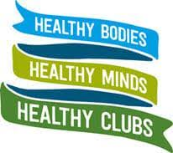
The GAA aims to play a real and important part in supporting the emotional wellbeing of not only our members but also communities. One way to help achieve this is to promote culture and activities that support healthy bodies, healthy minds and healthy clubs.
We would like to introduce the Healthy Clubs Committee for the coming year. Every club within the county has a Healthy Club Officer and each of our committee members are a designated contact for every club, and over the coming weeks will make contact with each club. We, as a committee will work with each club to ensure they have the correct supports, programmes and resources available to them.
Chairperson: Pauline McBride
Committee Members: Therese Bowden, Niamh Crudden, Fran Bolger, Cyril Kevlihan, Clare Coyle and Aoife Kane.
Upcoming events
Currently the HSE are running a 10-week information campaign for the area of Kildare and West Wicklow which aims to profile and raise awareness of bereavement supports and services that are available to people living in these areas.
Bereavement Support Campaign launched for Kildare West Wicklow - HSE.ie
There will also be online Healthy Club Officer training coming up on February 24th and March 31st. Further details will be issued nearer the dates.
Above committee members can be contacted through their designated club and will be more than happy to help with queries you may have.

I hope you enjoyed this week’s edition. Next week it is hoped to include a feature on Coaching & Games along with a fun trivia quiz.

Stay Safe
Dave Cahill
PRO Kildare GAA

