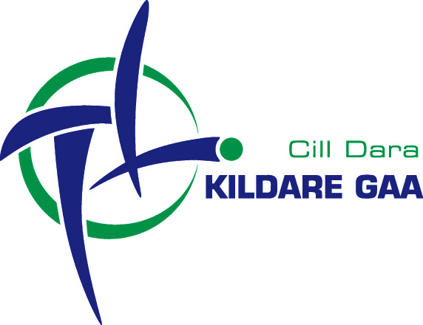
Kildare and Leinster Coaching & Games Development
Award 1 Child
Coaching Course.
Code: Hurling
Co-ordinator: John Doran
Phone Number: 0873629503

Fee: €50

SESSION | SESSION TITLE | STREAM | DATE | Time/ Venue
1. Room & Hall | Introduction, Communication & Role of Coach | Child | 9/10/17 | 7.00pm -9-30pm  Hawkfield
2. Room & Hall | Building & Breaking the Skills | Child | 16/10/17 | 7.00pm -9-30pm  Ardclough
3 Room & Hall | Adapting Games for Decision Making | Child | 23/10/17 | 7.00pm -9-30pm  Ardclough
4. Room & Hall | Family of Games | Child | 6/11/17 | 7.00pm -9-30pm  Ardclough
5. Room & Hall | Physical Literacy | Child | 13/11/17 | 7.00pm -9-30pm  Ardclough
6 .Room & Hall | U Can Awards & Why Children Play | Child | 20/11/17 | 7.00pm -9-30pm  Brady's Gym
7. Room | Lifestyle & Planning & Conclusion | Child | 27/11/17 | 7.00pm -9-30pm  Hawkfield

PLEASE NOTE THAT THIS COURSE IS FOR MENTORS INVOLVED WITH CHILDREN UNDER 12 YEARS OF AGE ONLY.

